**Assignment 1: Draw your Home Network Topology and explain how you are accessing the Any(College lab , office lab) Lab environment.**

Accessing the Lab Environment:

- When you want to access the lab environment from your personal devices at home, you would typically use a VPN client installed on your device. This VPN client connects to the VPN server set up by the college or office lab network.

- Once connected to the VPN, your device is effectively part of the lab network. You can access lab resources such as servers, databases, or specialized software as if you were physically present in the lab environment.

- The VPN ensures that your data is encrypted and secure as it travels between your home network and the lab network, protecting sensitive information from potential eavesdroppers or unauthorized access.

This setup allows you to work on lab projects, access research materials, or collaborate with colleagues/students from the comfort of your home while maintaining the security and integrity of the lab environment.

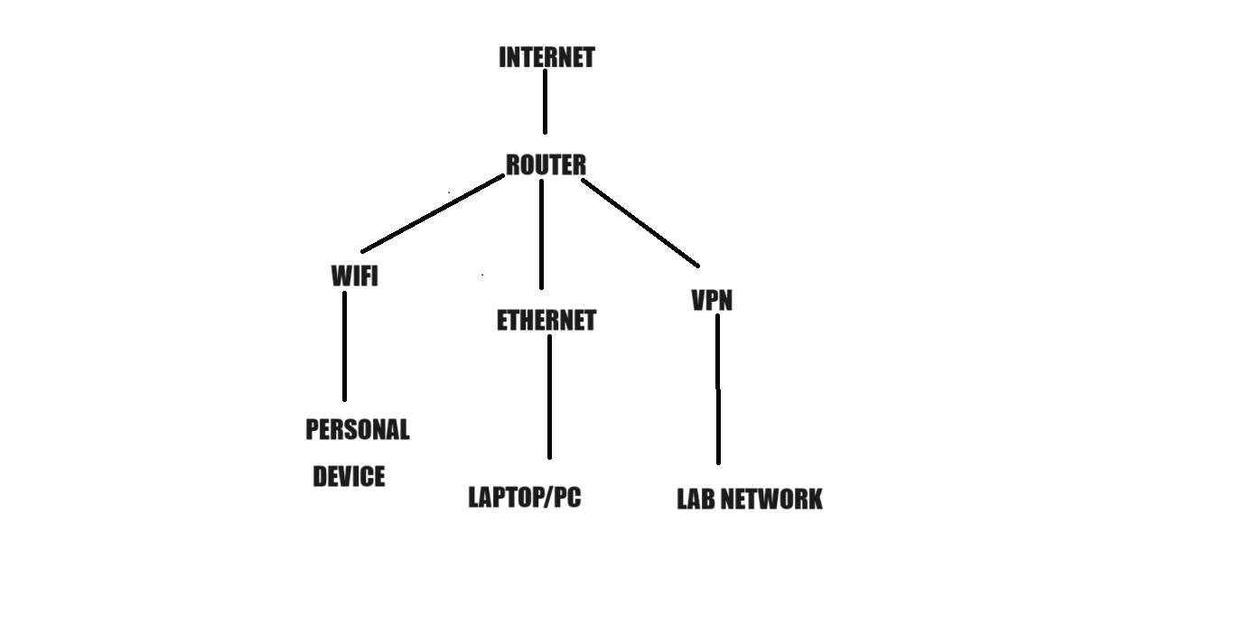

**Assignment 2: Identify a real-world application for both parallel computing and networked systems. Explain how these technologies are used and why they are important in that context.**

**Parallel computing**

Because computers can split large calculations into smaller ones and process them all at once, parallel computing is essential to weather forecasting. The generation of weather forecasts is substantially accelerated by this parallel processing. This technology is significant because it can make predictions more quickly and accurately, which helps a variety of industries, including emergency services, aviation, and agriculture, plan ahead and react appropriately. For example, airlines utilise weather data to more effectively plan flight routes, and farmers rely on timely weather forecasts to decide the best times to grow. Additionally, by enabling improved preparedness and response plans, parallel computing helps emergency services get ready for extreme weather occurrences like storms or hurricanes, improving public safety overall.

**Network systems**

By using computer technology and the internet to enable remote consultations between patients and healthcare practitioners, telemedicine transforms the way that healthcare is delivered. People no longer need to physically visit a clinic or hospital to get medical advice, acquire diagnoses, or even obtain prescriptions thanks to telemedicine. With the use of this cutting-edge method, patients may communicate with doctors through video conversations and present their symptoms, and doctors can view test results and medical records on digital platforms. As such, telemedicine improves healthcare accessibility and convenience, especially for those who live in rural places or have limited means of transportation. Furthermore, telemedicine is essential in preventing the spread of illness during public health emergencies or epidemics because it allows ill people to get the care they need while reducing the need for in-person visits to medical facilities. Telemedicine thus seems as a revolutionary